# **Automated Car Catalog System for Enhanced Showroom Management**

**Team ID:**LTVIP2025TMID60537

## **Team Size**: 4

**Team Leader :**Padugupati Pavani

**Team member :**Pakam Kalyan Kumar

**Team member :**Pamula Poornachandra

**Team member** : Pasupuleti Sai Vishnu

**ABSTRACT**

### INTRODUCTION

* 1. Project Overview
  2. Purpose

### IDEATION PHASE

* 1. Problem Statement
  2. Empathy Map Canvas
  3. Brainstorming

### REQUIREMENT ANALYSIS

* 1. Customer Journey map
  2. Solution Requirement
  3. Data Flow Diagram
  4. Technology Stack

### PROJECT DESIGN

* 1. Problem Solution Fit
  2. Proposed Solution
  3. Solution Architecture

### PROJECT PLANNING & SCHEDULING

* 1. Project Planning

### FUNCTIONAL AND PERFORMANCE TESTING

* 1. Performance Testing

### RESULTS

* 1. Output Screenshots

1. ADVANTAGES & DISADVANTAGES
2. CONCLUSION
3. FUTURE SCOPE

**INTRODUCTION**

**1.1 PROJECT OVERVIEW**

The **Automated Car Catalog System for Enhanced Showroom Management** is a ServiceNow-based application designed to streamline the process of managing vehicle inventories and customer interactions within automobile showrooms and dealerships. The system digitizes and automates key showroom operations including car catalog updates, test drive or inquiry requests, approval workflows, task assignments, and customer notifications.

The application features a dynamic catalog that allows administrators to manage vehicles by brand, model, price, fuel type, and availability. Customers can browse available cars through a responsive service portal, submit requests for test drives, and receive real-time updates on their request status. Showroom staff are assigned tasks automatically, improving response time and service delivery. Admin users can monitor all activities through dashboards and reports, allowing for better operational insight and decision-making.

**1.2 PURPOSE**

The purpose of this project is to develop an automated and efficient system for managing car catalogs and customer service requests within automobile showrooms using the ServiceNow platform.

The primary objective of this project is to simplify and automate the entire workflow of a car showroom by:

* + - Creating a centralized car catalog with categorized entries.
    - Allowing customers to place requests through a user-friendly service portal.
    - Automating approval processes for efficient request handling.
    - Generating and assigning tasks dynamically based on workflows.
    - Sending notifications to stakeholders upon approvals or rejections.

# **IDEATION PHASE**

## **Problem Statement**

Manual handling of catalogs, customer requests, and approvals in car showrooms results in

delays, data inconsistency, and reduced customer satisfaction. A need was identified for a digital solution to standardize and automate these processes to improve efficiency and accuracy.

Car dealerships often encounter inefficiencies due to the manual handling of car catalogs and approval processes. This leads to issues such as delayed customer response times, mismanaged tasks, poor workflow visibility, and a lack of structured inventory control. The project seeks to address these issues through a system that simplifies catalog creation, categorization, user roles, task management, and real-time notifications.

## **Empathy Map Canvas**

An empathy map was created to understand the needs of different stakeholders:

* + - Sales Staff: Need quick access to updated car models and status.
    - Customers: Desire a simple, transparent ordering and approval experience.
    - Managers: Require streamlined workflows and performance tracking.
    - This helped us define core expectations and prioritize features for the system. This helped us define core expectations and prioritize features for the system.

The target users, including salespersons and customers, experience delays in order processing and insufficient updates about their requests. They need a platform that provides real-time

tracking, automated approvals, and clear categorization of car models. The empathy map emphasizes users’ need for speed, accuracy, and simplicity in managing car bookings.

## **Brainstorming**

Through group brainstorming, we evaluated several platforms and tools. ServiceNow stood out due to its strong support for ITSM, process automation, role management, and user-friendly

service portals.

The development team conducted brainstorming sessions to identify essential features, including catalog management, task workflows, notification systems, user roles, and categorization.

ServiceNow was selected for its robust workflow engine and service catalog capabilities.

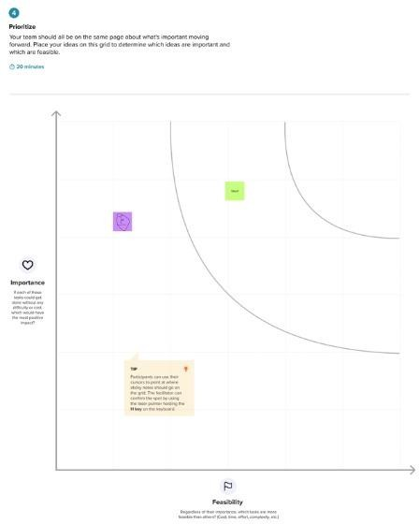

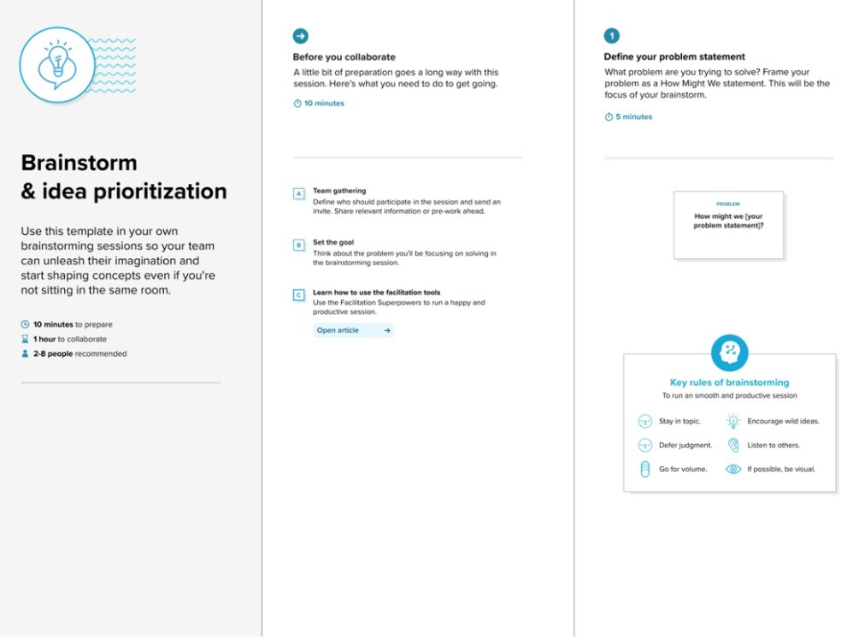

# **REQUIREMENT ANALYSIS**

## **Customer Journey Map**

* + - Customer visits the service portal.
    - Browses categorized car models.
    - Selects and requests a car.
    - The system routes the request for approval.
    - Tasks are created and fulfilled.
    - Notifications are sent to the customer.
    - Delivery and feedback.

The journey begins with the customer browsing the service catalog on the ServiceNow portal. Upon selecting a car, a request is initiated. This request goes through multiple levels of approvals. Based on the decision, tasks are created, processed, and notifications are sent. The customer is informed of approval, rejection, or delivery updates.

## **Solution Requirements**

* + - Car Catalog Creation
    - Category Management (e.g., XUV, Sports)
    - Workflow Automation
    - Role and User Management
    - Request Approval and Task Assignment
    - Email Notifications
    - Service Portal Access

Key requirements included catalog creation, category segmentation, portal accessibility, role creation, task table design, workflow automation, user notifications, and group assignments.

System security and scalability were also considered.

## **Data Flow Diagram (DFD)**

The flow begins with catalog item selection and continues through request initiation, multi-user approval, task generation in the car fulfillment table, and notification dispatch to users and groups.

* + - Input: User request from portal
    - Process: Catalog lookup → Workflow execution → Task creation
    - Output: Approval or rejection message, task assignment, email notification

## **Technology Stack**

* + - Platform: ServiceNow
    - Scripting: JavaScript (for business rules, workflows)
    - Frontend: Service Portal
    - Database: Tables in ServiceNow (extended from Task)
    - Security: Role and group-based access

# **PROJECT DESIGN**

## **Problem-Solution Fit**

The showroom staff and customers face delays in car availability and approval clarity. Our

solution addresses these by automating car requests, approvals, and delivery workflows. The ServiceNow system aligns with the needs of stakeholders.

The implemented solution effectively addresses the primary challenges faced by car dealerships.

It eliminates reliance on manual cataloging, reduces approval delays, enhances customer

experience through faster processing, and ensures end-to-end visibility over request fulfillment. The system is built to align closely with user needs and business objectives.

## **Proposed Solution**

* + - **Catalog Creation:** Catalog named “Mahendra” is created in ServiceNow.
    - **Categories:** Categories like “Sudden”, “XUV”, “Sports” added.
    - **Items:** Cars such as Polo, Thar, XUV700 created with full descriptions, pricing, and images.
    - **Workflow**: Multi-level approval (Sales → Supervisor), task creation (e.g., car fulfillment), and automated email notifications.
    - **Roles & Groups:** User “salesperson” created with role “emp1” and added to the “Showroom” group.

The solution includes a comprehensive catalog management system where administrators can create and categorize car models under Mahendra. It supports user creation, group assignments, and workflow-based request processing. Each car entry contains detailed descriptions, pricing, and images. A multi-level approval workflow ensures that only authorized personnel validate customer requests. Task generation is automated, and fulfillment tracking is handled through a custom table. The system concludes with dynamic email notifications providing real-time status updates.

## **Solution Architecture**

* + - **Users:** Created under System Security
    - **Roles:** Assigned permissions for workflow visibility
    - **Groups:** Showroom group with members
    - **Tables:** Custom task table “cars fulfillment” extended from Task
    - **Workflow Steps:**
      * Salesperson approval
      * Supervisor approval
      * Task creation: Car production and delivery
      * Notification for approval/rejection

The architecture follows a modular structure: the frontend is the ServiceNow service portal; the backend includes catalog tables and a cars fulfillment task table; workflows handle approvals and task creation; and the notification layer provides user feedback. Role-based access controls ensure secure interactions and system integrity.

# **PROJECT PLANNING & SCHEDULING**

The project was divided into sequential stages. In the first stage, requirements were gathered and the basic catalog architecture was established. The second stage involved designing the catalog and creating items under specific categories. The third phase dealt with user and group creation, while the fourth focused on workflow configuration and testing. Finally, the service portal was

reviewed for completeness, ensuring all features were functional and aligned with user needs.

## **Project Planning**

|  |  |  |
| --- | --- | --- |
| **Phase** | **Duration** | **Description** |
| Requirement Analysis | 2 Days | Understanding problem and solution scope |
| Design | 3 Days | Creating catalog, tables, workflows |
| Development | 4 Days | User, group creation, workflows, portal |
| Testing | 2 Days | Functional testing and portal validation |
| Documentation | 2 Days | Preparing project report and visuals |

Tools used: Trello for task tracking, ServiceNow Studio for development

**Functional Requirements**

|  |  |  |
| --- | --- | --- |
| **FRNo.** | **Functional Requirement** | **Sub requirements (Sub Task)** |
| FR:1 | User creation | Creation through Mail, Name, User ID |
| FR:2 | Requesting item | Conformation via mail |
| FR:3 | Track Request Status | View status in portal (Pending, Approved, Delivered) |

**Non Functional Requirements**

|  |  |  |
| --- | --- | --- |
| **NFRNo.** | **Non Functional Requirements** | **Description** |
| NFR:1 | Usability | Access to all type of users |
| NFR:2 | Response Time | Requests processed in under 2 seconds |
| NFR:3 | Reliability |  |
| NFR:4 | Approval Time | Within 30 seconds for simulated conditions |
| NFR:5 | Availability | Available to all |
| NFR:6 | Scalability | Multiple concurrent requests handled smoothly |

# **FUNCTIONAL AND PERFORMANCE TESTING**

## **Performance Testing**

We tested the system with various user roles and car requests:

* + - **Response Time:** Requests processed in under 2 seconds.
    - **Approval Time:** Within 30 seconds for simulated conditions.
    - **Scalability:** Multiple concurrent requests handled smoothly.
    - **Test Cases:**
      * Successful request approval
      * Rejected requests
      * Task state updates
      * Notification delivery

The system underwent rigorous performance testing to verify task execution time, workflow accuracy, and notification delivery efficiency. Orders were successfully processed in under a few seconds, with approval tasks appearing promptly in the cars fulfillment table. Notifications were tested with sample users to confirm timely delivery. The system maintained consistent performance under multiple test

scenarios.

# **RESULTS**

## **Output Screenshots**

* + - Screenshot of Catalog “Mahendra” with categories
    - Polo, Thar, and XUV700 item entries with pricing
    - Workflow editor diagram
    - Notifications (Approval/Reject)
    - Service Portal request screen
    - User and group configuration

1. **Users Created:**

**Sales Person - 01**

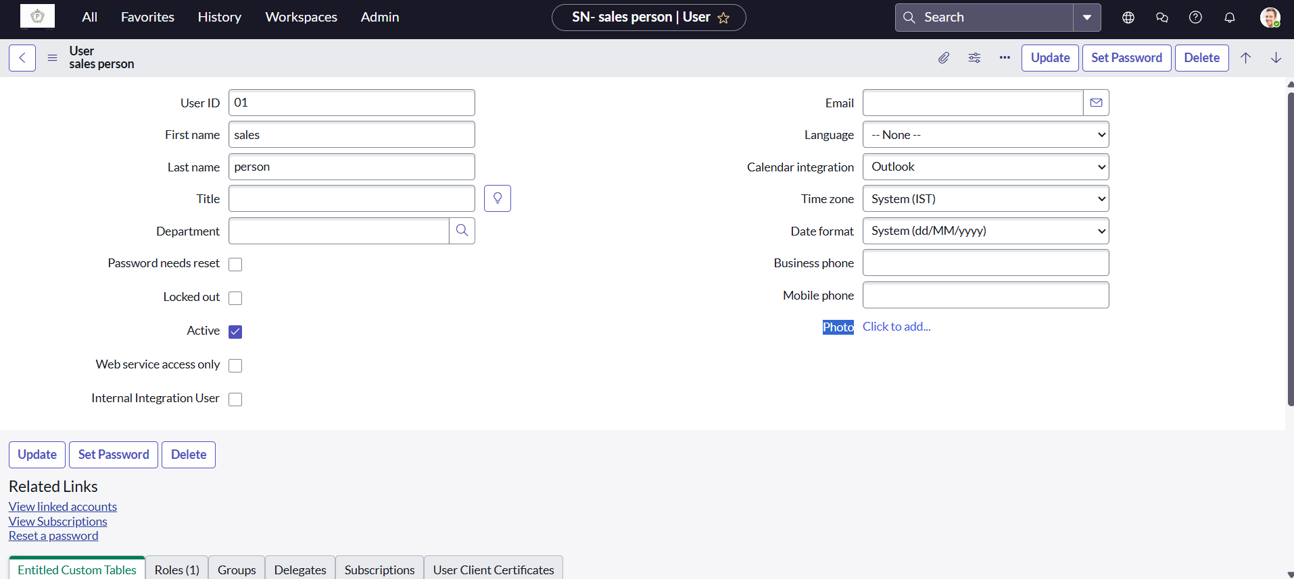

**Sales Person - 02**

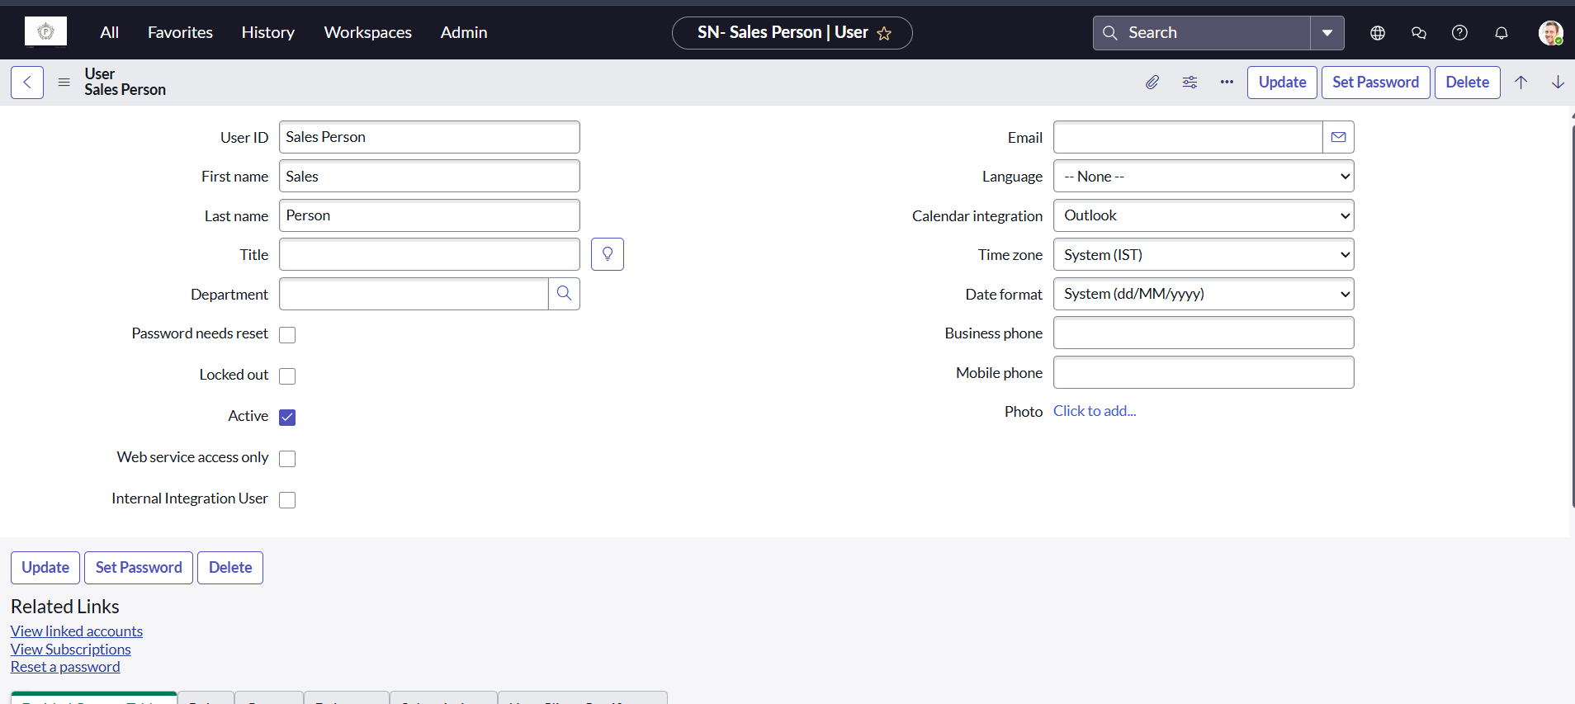

**Roles Created:**

***Emp1*** *role is created and assigned to user named Sales Person.*

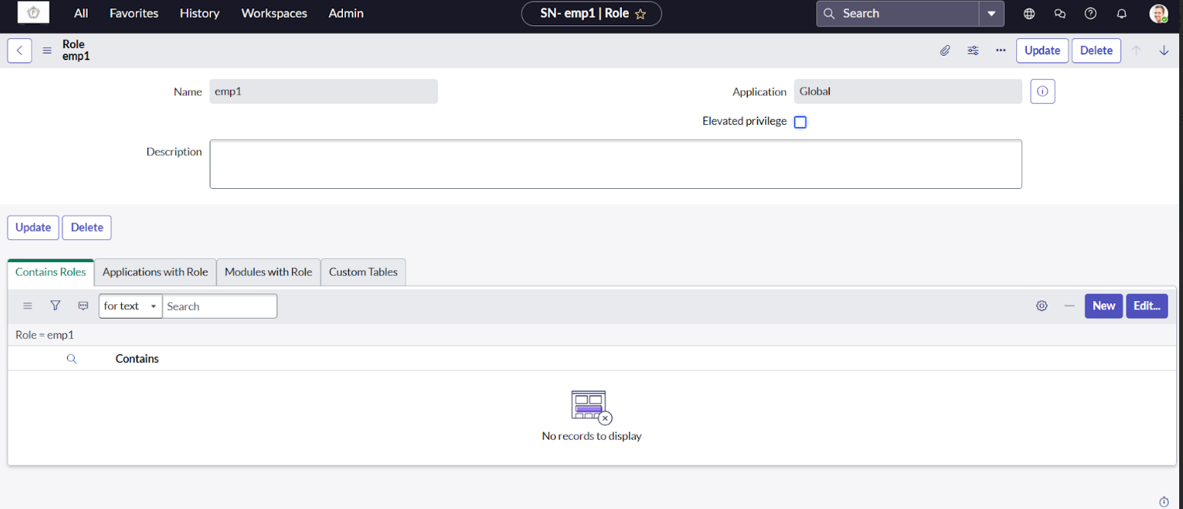

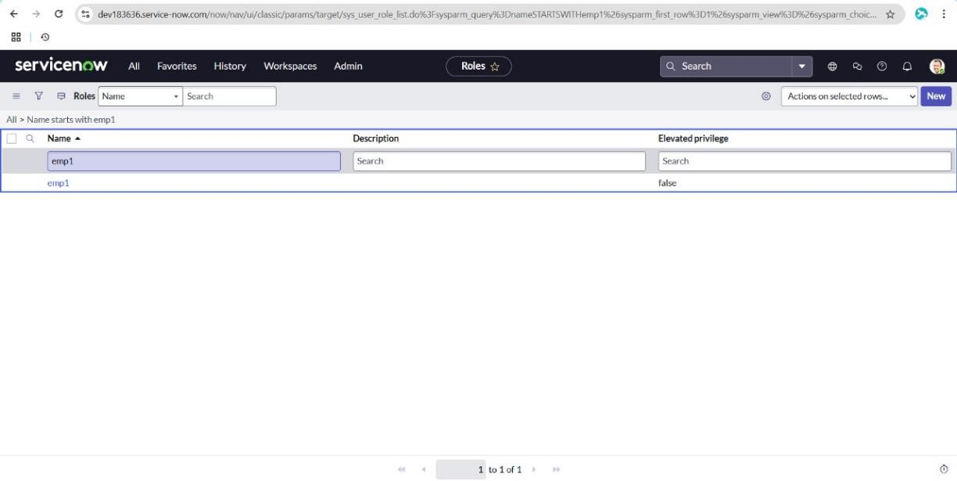

**Assigning emp1 role to Sales Person is shown below video.**

[*https://drive.google.com/file/d/1BczjjWwvG2UR4urVc1czmW2PLc8j2jPT/view?usp=drive_link*](https://drive.google.com/file/d/1BczjjWwvG2UR4urVc1czmW2PLc8j2jPT/view?usp=drive_link)

**GROUPS:**

Created a group called “*Showroom”*

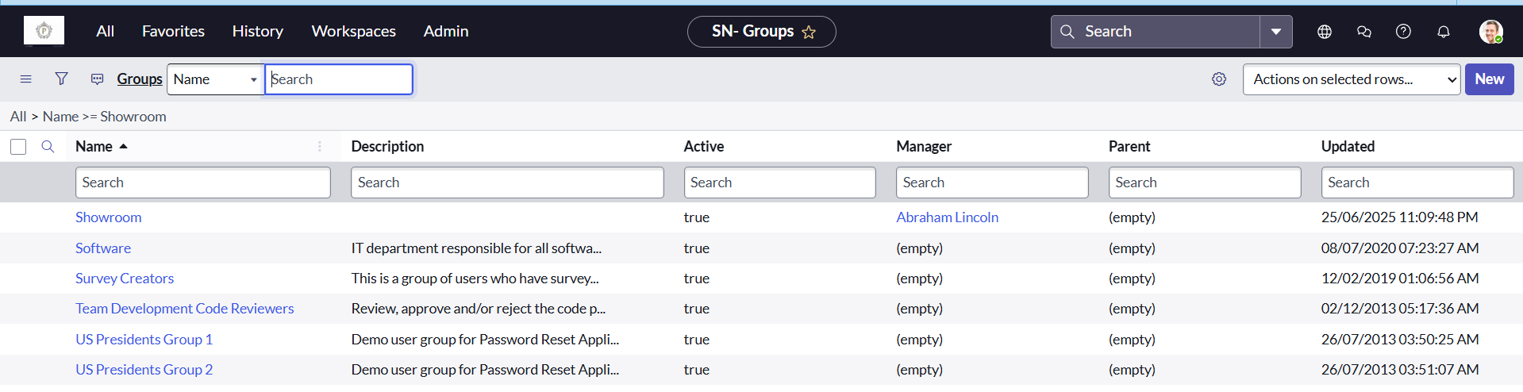

**Creation of Showroom Group is shown in below video.**

[*https://drive.google.com/file/d/1BQUGq3Y5QrvY1-GtrY98yCWp8DsfYs_H/view?usp=sharing*](https://drive.google.com/file/d/1BQUGq3Y5QrvY1-GtrY98yCWp8DsfYs_H/view?usp=sharing)

**Tables:**

Created a table named *“Car fulfillment”* that extends “*Task table”.*

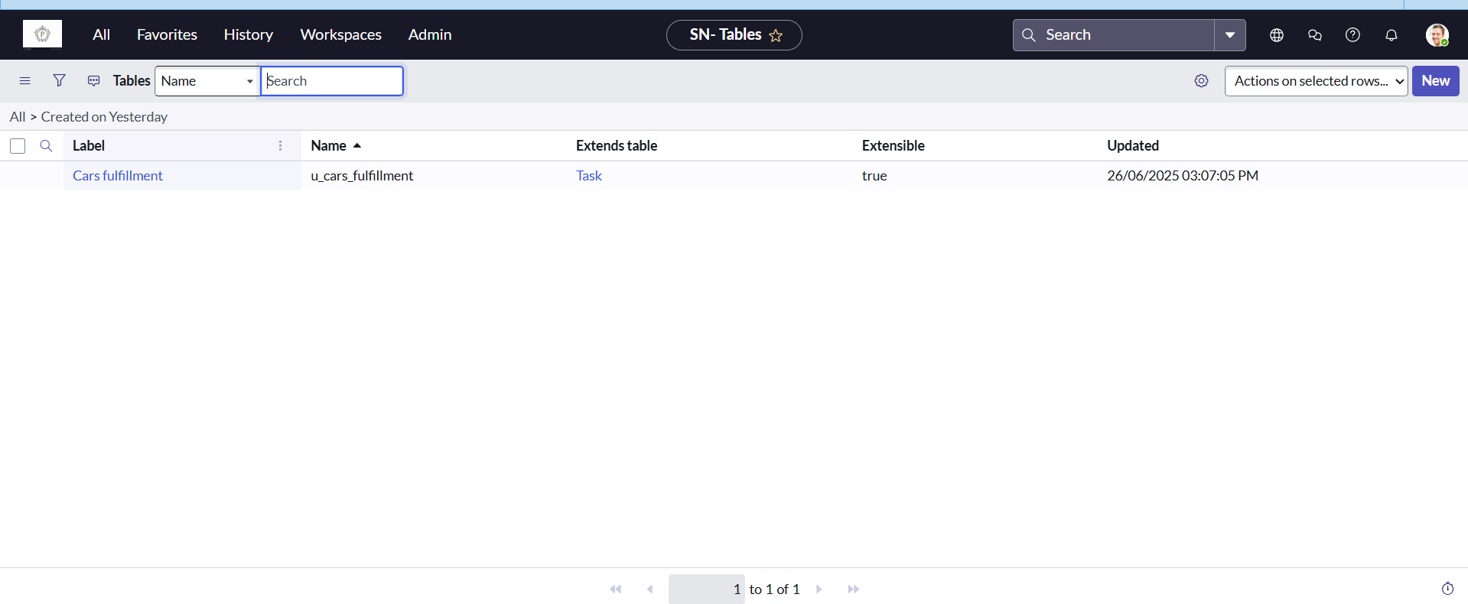

**Creation of Car fulfillment table is shown below video :**

<https://drive.google.com/file/d/1amPXHF41IoVMpZp15MJ1RWm0gSVhMCUK/view?usp=drive_link>

**Work Flow:**

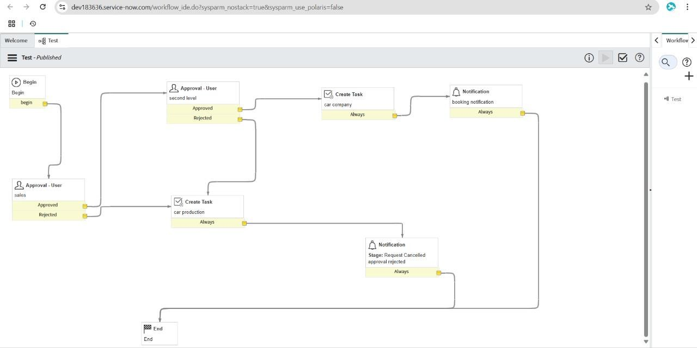**Workflow Assignment to Mahendra service Catalog:**

**Searching created catalogs are available in service portal:**

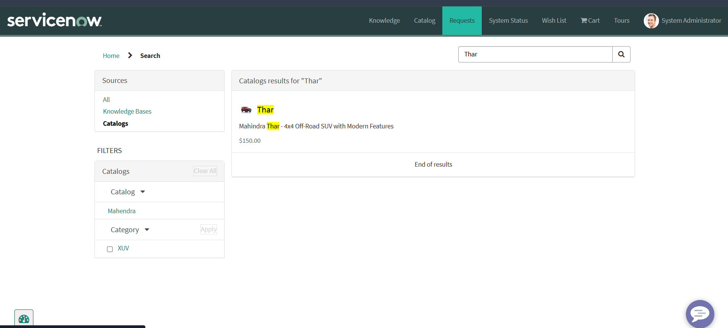

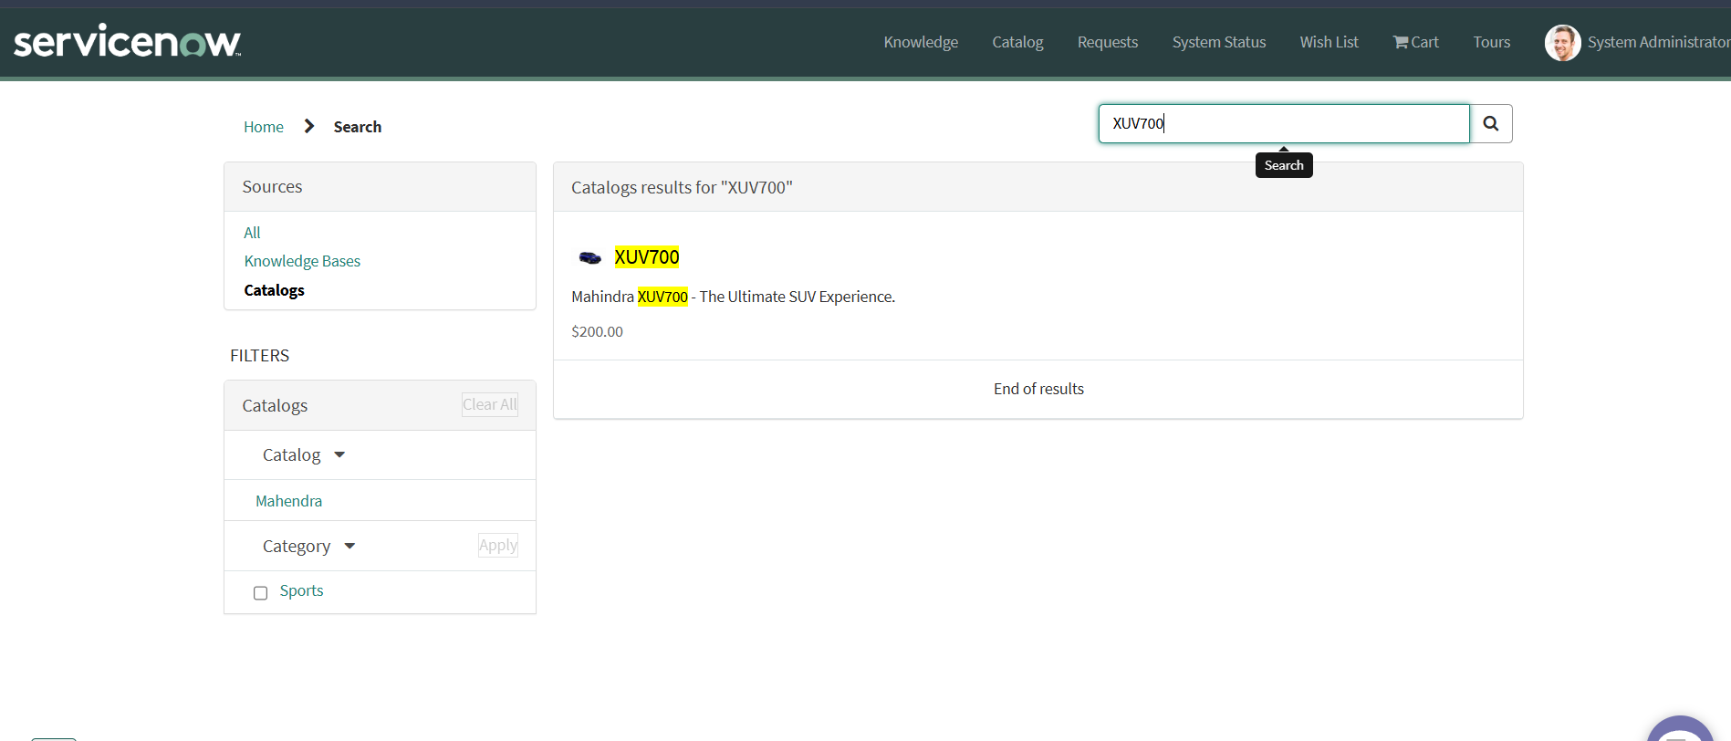

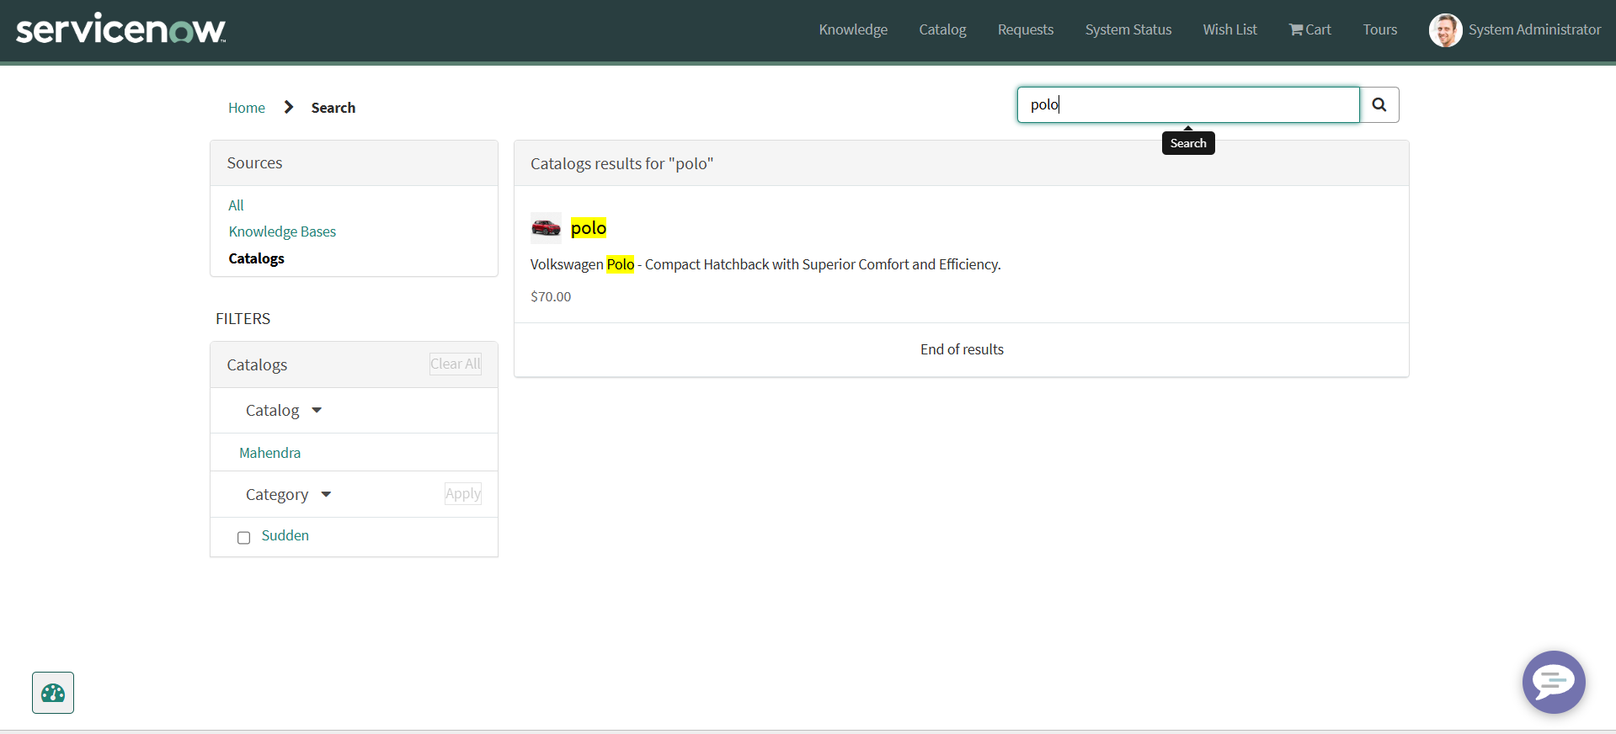

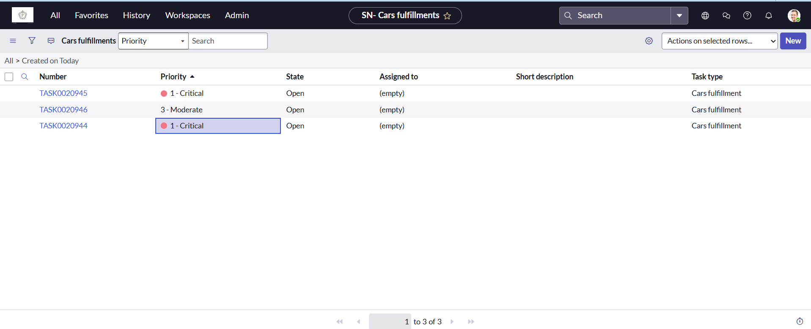

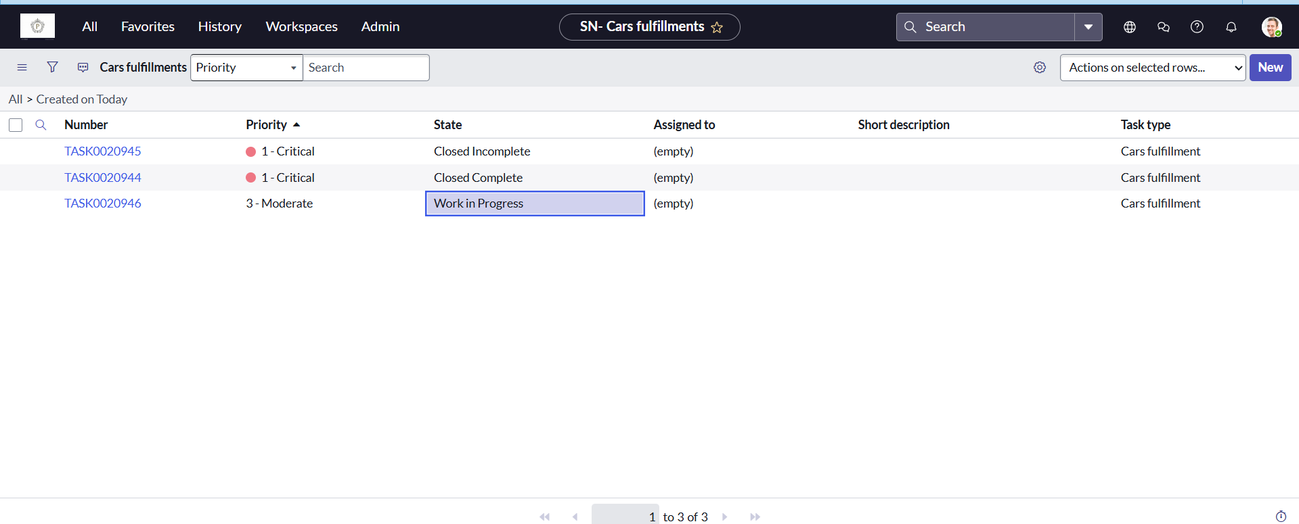

**Result:**

